A000-AM,C-Taino- *potiza* -bottle-iguana-terra cotta-1000 CE

This intact ceramic *potiza* bottle is in excellent shape. A large iguana or lizard is molded into the side. Taino pottery often exhibits animals of the Caribbean. There are dark areas of flashing caused by exposure to fire common in pit firings. This piece is 19.9 cm. or 7.8 in. tall. It is originally from the Dominican Republic and dates ca. 1000-1500 C.E.

Case no. 18

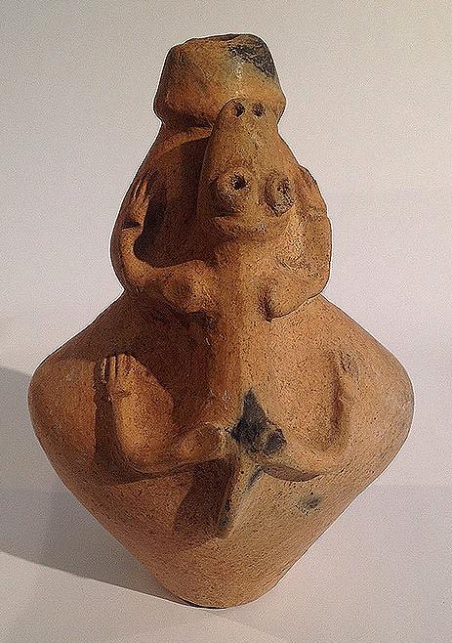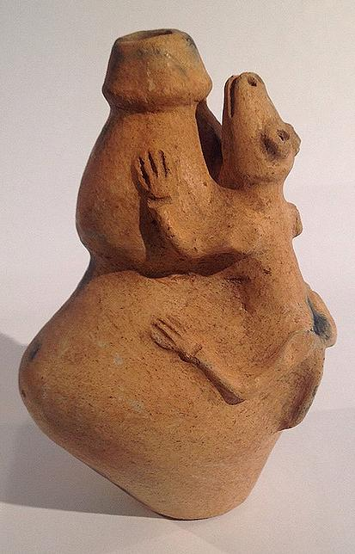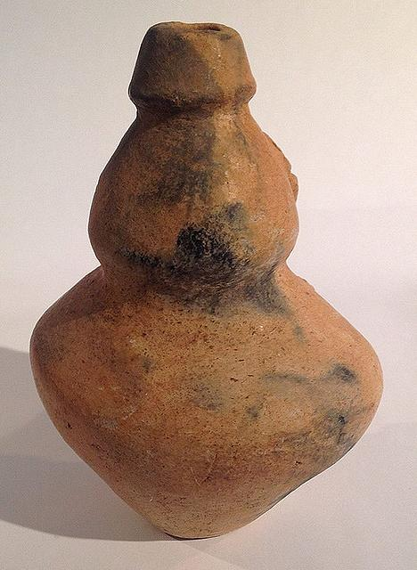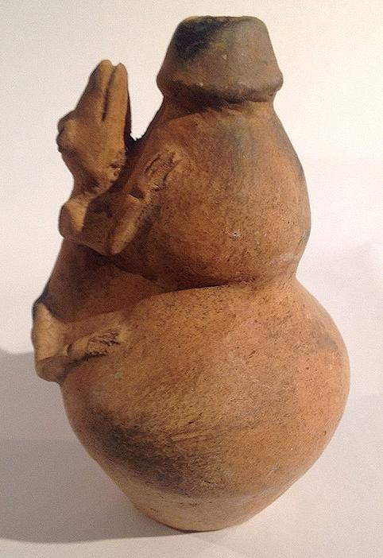

Sold by [flapast](http://myworld.ebay.com/flapast) ( [13311](http://feedback.ebay.com/ws/eBayISAPI.dll?ViewFeedback&userid=flapast) )

### Delivery package 1 of 1

Estimated delivery Monday, Jan 25, 2016

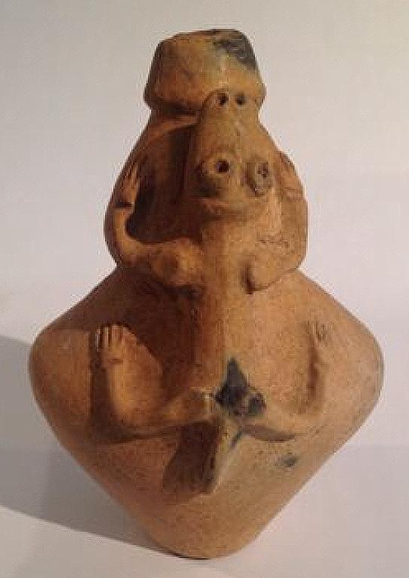

#### [Taino Pottery Bottle With Figural Iguana, Pre Columbian](http://www.ebay.com/itm/252240632822)

|  |  |
| --- | --- |
| Item price | $250.00 |
| Quantity | 1 |
| Item number | 252240632822 |
| Shipping service | USPS Priority Mail |

## Shipping address

Ralph J Coffman Jr

149 Atlantic Ave

Swampscott MA 01907-2427

United States

## Order total

|  |  |
| --- | --- |
| Subtotal | $250.00 |
| Shipping | $12.00 |

**Total**

$262.00

Order placed on

Saturday, Jan 16, 2016

Payment method

PayPal

Payment date

Saturday, Jan 16, 2016